GW Instek AFG-2025

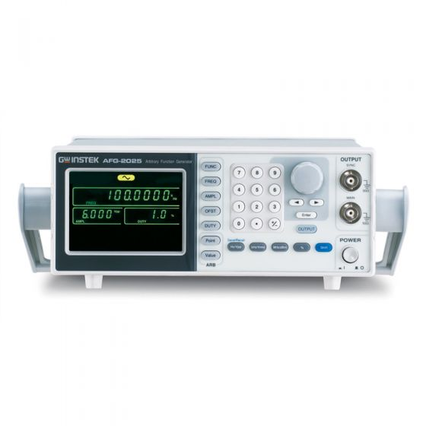

|  |  |
| --- | --- |
| Url | https://www.instrumentation2000.com/gw-instek-afg-2025.html?srsltid=AfmBOorJMMcnS7Q3GecHSMvTHlIm7RYJLgoG8ok4E0dJPtc8YR_cjvu_ |
| Video | https://www.youtube.com/watch?v=AP2teM0zNNE |

### Key Features:

* 0.1Hz to 5/12/25 MHz with in 0.1Hz Resolution
* Sine, Square, Triangular, Noise and Arbitrary Waveform
* 20MSa/s Sampling Rate, 10 bit Vertical Resolution and 4k Point Memory for Arbitrary Waveform
* 1% ~ 99% adjustable duty cycle for Square Waveform
* Waveform Parameter Setting Through Numeric Keypad Entry & Knob Selection
* Amplitude, DC Offset and Other Key Setting Information Shown on the 3.5” LCD Screen Simultaneously
* AM/FM/FSK Modulation, Sweep, and Frequency Counter Functions (AFG-2100 only)
* USB Device Interface for Remote Control and Waveform Editing
* PC Arbitrary Waveform Editing Software